**Topological Investigations into Electromagnetism**

Todd Lincoln

Michigan State University

**Introduction**

The goal of topological research into electromagnetic fields is to discern whether they can be obtained from the structure of spacetime manifolds. This can come from either from its geometrical structure, like the gravity, its topological structure, or some combination of both. By investigating the reformulation of electricity and magmatism through a topological lens a more fundamental understanding of electricity, magnetism and how that relate to other forces may be achieved leading to new discoveries. Topology is useful for constructing the most fundamental physical explanation of a system, by describing a model off of empirical facts. “For example, differential equations of motion cannot be fundamental, because they are dependent on boundary conditions which must be justified-by a group” [1]. With the topology known, the group theory and group transformations can be justified which in turn justify the algebra underlying the differential equations. “It can be shown that all the methods of solving differential equations are special cases of integration procedures based on the invariance under a continuous symmetry group” [1]. This is more explicit in Noether’s theorems which relate a symmetry group of an integral to its associated Euler-Lagrange equations. This gives way to 3 important consequences.

1. Conservation of energy comes from invariance under time translations
2. Conservation of linear momentum comes from invariance under translational groups
3. Conservation of angular momentum comes from invariance under rotational groups

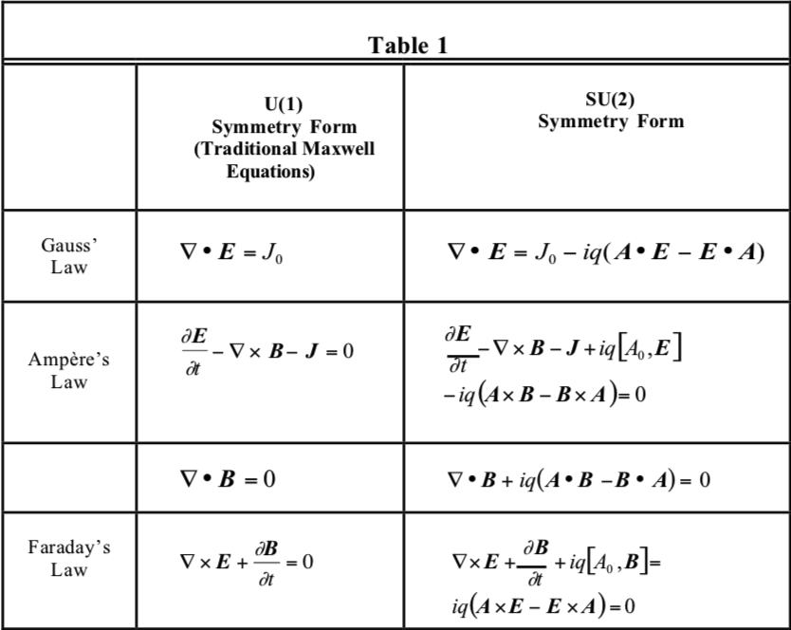Ultimately the goal is to show that spacetime topology defines electromagnetic field equations. Or alternatively, “field equations are only valid with respect to a set defined topological description of the physical situation.” [1]. This may take form of ***A***μ potentials where in “certain well-defined situations” theyare measurable, i.e., physical. Situations in which the ***A***μ potentials are measurable possess a topology, describable by the *SU(2+)*, and situations in which the ***A***μ potentials are not measurable possess a topology, describable by the *U(1)* group.

Classical E&M (Maxwell equations) was developed for situations described by the U(1) group. However there is a need to extend these equations to SU(2). These formulations are shown in Figure 1and Figure 2.

Figure 1

If topological notation/diction needs to be explained but not directly used as an argumentative case for topological E&M it will be denoted by a: notationn where n is the index. The description/definitions will be located at the end of the paper.

**Solitons**

A soliton is a solitary wave which preserves its shape and speed in a collision with another solitary wave. Soliton solutions to differential equations require complete integrability. Integrable solutions systems conserve geometric features related to symmetry. Solitons are solutions of SU(2) symmetry systems, but recall classical E&M is a U(1) symmetric system. Within this context, ordinary differential equations are viewed as vector fields on manifolds. (a manifold is a topological space that locally resembles Euclidean space near each point) Noether’s theorem states that a diffeomorphism1 φ of a Riemannian manifold, *C*, indices a 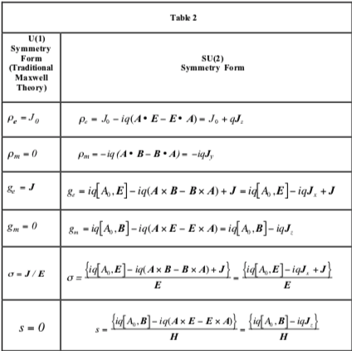diffeomorphism, Dφ , of its tangent2 bundle3, *TC*. If φ is a symmetry of Newton’s equations, then *D*φ preserves the Lagrangian:

$$L∘D =L$$

“soliton flows are Hamiltonian flows. Such Hamiltonian functions define symplectic structures”[1]. Which means there is an absence of local invariants but an infinite dimensional group of diffeomorphisms which preserve global properties. In the case of solitons, the global properties are those permitting the matching of the nonlinear and dispersive characteristics of the medium through which the wave moves. In order to relate the three major soliton equations to group theory, it is necessary to examine a Lax equation or the *zero-curvature condition* (ZCC). The ZCC expresses the flatness of a connection by the commutation relations of the covariant derivative operators[1]:

Figure 2

$$A_{t}-B_{x}-\left[A,B\right]=0$$

Reformulated to as a Lax equation:

$$\left[ \frac{∂}{∂x}-A,\frac{∂}{∂t}-B\right]=0$$

In the case of the soliton the Korteweg de Vries Equation, the Nonlinear Schrödinger Equation and the Sine-Gordon Equation can be given an SU(2) formulation[2].(For a full derivation see Palais, R.S., The symmetries of solitons pg. 380-385). Thus, if the Maxwell equation of motion with electric *and* magnetic conductivity is in soliton, the group symmetry is *SU(*2*)*. Solitons define Hamiltonian flows and their energy conservation is due to their symplectic structure. In order to clarify the difference between conventional Maxwell theory which is of *U(*1*)* symmetry, and Maxwell theory extended to *SU(*2*)* symmetry, we can describe both in terms of mappings of a field $ψ\left(x\right).$ In the case of *U(*1*)* Maxwell theory, a mapping $ψ→ψ^{'}$ is:

$$ψ\left(x\right)→ψ^{'}\left(x\right)=e^{ia\left(x\right)}ψ(x)$$

Where a(x) is the conventional vector potential. However, in the case of *SU(*2*)* extended Maxwell theory, a mapping $ψ→ψ^{'}$ is

$$ψ\left(x\right)→ψ^{'}\left(x\right)=e^{iS\left(x\right)}ψ(x)$$

Where S(x) is the action and an element of *SU(*2*)* defined:

$$S\left(x\right)=∫Adx$$

and ***A*** is the matrix form of the vector potential. Therefore we see the necessity to adopt a matrix formulation of the vector potential when addressing *SU(*2*)* forms of Maxwell theory.

**Instantons**

Instantons correspond to the minima of the Euclidean action and are pseudo-particle solutions of *SU(2)* Yang-Mills equations in Euclidean 4 space [3]. The topological features of instantons are further explained by:

“If one were to search ab initio for a non-linear generalization of Maxwell’s equation to explain elementary particles, there are various symmetry group properties one would require. These are

1. *external symmetries* under the Lorentz and Poincaré groups and under the conformal group if one is taking the rest-mass to be zero,
2. *internal symmetries* under groups like *SU(2)* or *SU(3)* to account for the known features of elementary particles,
3. *covariance* or the ability to be coupled to gravitation by working on curved space-time.”[4]

Instantons contribute to the topological theory because: The instanton would share characteristics with real high energy particle, and it is a compactification of degrees of freedom due to boundary conditions. This would explain the Mikhailov and Ehrenhaft effects, which demonstrate magnetic charge-like behavior.

**Effects not described by Classical E&M**

There are some phenomena that cannot be explained by the conventional Maxwell theory. The conventional Maxwell theory must be extended, or generalized, to a non-Abelian form. It explains, the majority of cases in electromagnetism, however it is the topology of the spatiotemporal situation that can explain the outlying effects. The most basic explanation of electromagnetic phenomena and their physical models lies not in differential calculus or group theory, but in the topological description of the (spatiotemporal) situation. [5]

**Aharonov – Bohm Effect**

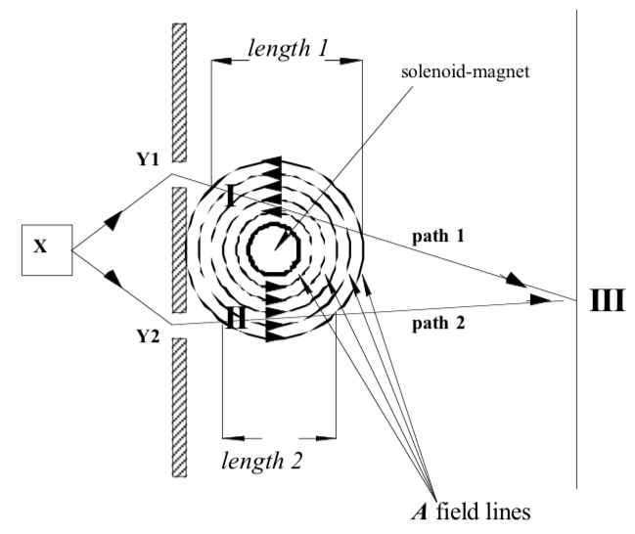A good example of topological explanation of electromagnetism is the Aharonov – Bohm Effect.[5] The basis of the of the experiment is that the vector potential does produce real observable effects. The experimental set up was as follows: A beam of monoenergetic electrons are emitted from a source X and diffracted at 2 slits in a wall at Y1 and Y2. The beams produce an interference patterns at position III. Behind the wall there is a solenoid magnet that produces a magnetic field out of the paper. The absence of magnetic monopoles predicts that the field outside of the solenoid is 0. While the solenoid is turned off a normal and calculable interference pattern is observed at III. Aharonov and Bohm predicted that the differently directed A fields along path 1 and path 2 would produce discernable phase shifts at III. They were correct and the Experiment has been duplicated and extensively reviewed. [1]

A possible interpretation of the results is the fundamental topology dictates this effect. The key feature is a topological obstruction due to the solenoid itself. Due to the solenoid you cannot reduce the interferometer’s possible paths to a single point. With the existence of the solenoid, the region occupied by this special interferometer is multiply-connected, since it cannot be reduced to a single path. If that situation were simply-connected. The situation could be described by U(1) electromagnetics and the mapping from one region to another is conventionally one-to-one. However, as the Aharonov-Bohm situation is multiply-connected, there is a two-to-one mapping (SU(2)/Z2) of the two different regions of the two paths to the single region at III [1]. The measurement at III is made of “*the differential histories* of the *two* test waves which traversed the *two* different paths and experienced *two* different forces” [1]. resulting in two different phase effects. In conventional, *U(1)/*simply-connected situations, if there is a vector field, is pointing in one direction, and a particle enters from a direction on one of the side and there are vectors pointing in the opposite direction with a particle enters from the same direction, but on the other side, has the same effect or to say there is no concern of the direction of the vectors. Because if a field is of U(1) symmetry and can be reduced to a single point. Therefore in most cases which are of U(1) symmetry, we do not need to distinguish between the direction of the vectors of a field from one region to another of that field. In the case of the Aharonov – Bohm experiment the multi-connectedness the direction of the A field on the separate paths is important, because a test wave traveling along one path will experience an equal and opposite A field components that either apply positive or negative accelerations to their motion. These changes in motion can be measured as phase changes. If measurements are attempted at locations I or II these effects will not be seen because there is no two-to-one mapping at those locations. That is to say physically the locations I and II are both simply-connected with the source and therefore only the conventional U(1) electromagnetics applies at these locations. You can only measure the phase shift at location III which is multiply-connected with the source.

To distinguish the potentials of *U(1) and SU(2)/Z2* = *SO(3) at III* ***A***μ, at I and II will be lowercase ***a***μ, *μ* = 0,1,2,3 and at III upper case ***A***μ, *μ* = 0,1,2,3. Similarly, the electromagnetic field tensor at I and II, use the lower case, $f_{μν}$, and for the electromagnetic field tensor at III, uses the upper case, $F_{μν}$ Then the following definitions for the electromagnetic field tensors are:

$$f_{μν}\left(x\right)= ∂_{ν}a_{μ}\left(x\right)-∂_{μ}a_{ν}(x)$$

$$F_{μν}\left(x\right)= ∂_{ν}A_{μ}\left(x\right)-∂_{μ}A_{ν}\left(x\right)-ig_{m}[A_{μ}\left(x\right),A_{ν}\left(x\right)]$$

Where $f_{μν}\left(x\right)$ is Abelian and gauge invariant, $F_{μν}\left(x\right)$ is gauge covariant, and $g_{m}$ is the magnetic charge density. Note that the situation is 2-dimentiaional. “Aharonov-Bohm effect is defined only in the *x* and *y* dimensions *SU(2)/Z2* symmetry *requires* a field to be oriented differentially on the separate paths” [5].

The typical explanation of the Aharonov-Bohm effect starts with the Lorentz Force:

$$F=qE+qv× B$$

The electric field, ***E***, magnetic field, ***B***, act for the most part on the inside of the solenoid and therefore don’t influence the electrons that much. First we argue that the E,B fields can be expressed in terms of the A and φ potentials:

$E= -\frac{∂A}{∂t}\left(-∇\right)$, $B= ∇×A$

Expanding to SU(2):

$E= -\left(∇×A\right)-\frac{∂A}{∂t}\left(-∇\right)$, $B=\left(∇×A\right)-\frac{∂A}{∂t}(-∇)$

Then the Lorentz force of our formulation in SU(2) is:

$$F=q\left(-\left(∇×A\right)-\frac{∂A}{∂t}\left(-∇\right)\right)+qv×(\left(∇×A\right)-\frac{∂A}{∂t}\left(-∇\right))$$

The Aharonov-Bohm effect continues with the observation that a phase difference δ between the two test electrons is caused by the presence of the solenoid:

$$∆δ=Δα_{1}-Δα_{2}= \frac{q}{ℏ}(\int_{l_{2}}{A∙dl_{2}-\int_{l_{2}}{A∙}dl_{2})= }$$

$$\frac{q}{ℏ}\int_{l_{2}-l_{1}}{∇×A∙}dS= \frac{q}{ℏ}∫B ∙dS= \frac{q}{ℏ}ψ_{M}$$

Where $Δα_{1},Δα_{2}$ are the changes in wavefunction r the electrons in the two paths S is the surface area and $ψ_{M}$ the magnetic flux defined as:

$$ψ_{M}=∫∫A_{μ}\left(x\right)dx^{μ}=∫∫F_{μν}dσ^{μν}$$

Now, we can extend this explanation further, by observing that the local

phase change at III of the wavefunction of a test wave or particle is given by:

$$Φ=e^{ig_{m}∫∫A_{μ}\left(x\right)dx^{μ}}=e^{ig_{m}ψ_{M}}$$

$Φ$ which is proportional to the magnetic flux, $ψ_{M}$, is known as the phase factor and is gauge covariant. It is measured at position III is the holonomy4 of the connection5, **A**μ; and gm is the SU(2) magnetic charge density. $∆δ$ and $Φ$ are dimensionless. ∇ × ***A*** = 0 outside the solenoid. An electron on path 1 will interact with the ***A*** field oriented in the positive direction. Conversely, an electron on path 2 will interact with the ***A*** field oriented in the negative direction. The ***B*** field can be defined with respect to a local stationary component ***B****1* which is confined to the solenoid and a component ***B****2* which is either a standing wave or propagates. [1]:

$$B=B_{1}+B_{2}$$

$$B_{1}= ∇×A$$

$$B_{2}= -\frac{∂A}{∂t}(-∇)$$

$B_{2}$ is a standing wave that is associated with SU(2). In U(1) $B_{1}$ components are associated with the field and $B_{2}=0$. The electrons traveling on paths 1 and 2 require different times to reach III due to the different distances and the opposing directions of the potential ***A*** along their paths The change in the phase difference due to the presence of the ***A*** potential is:

$$∆δ=Δα_{1}-Δα_{2}=$$

$$\frac{q}{ℏ}∫B ∙dS= \frac{q}{ℏ}ψ_{M}$$

**Summary**

This paper attempted to show how topological foundations of electromagnetism can be explains and an example case the Aharonov-Bohm effect to show case when the classical theory breaks downs and topological analysis can lead to a solution. solitons, instantons were also addressed ad they play an important role if topological explanations are to be generalized to a field theory. Given a Yang-Mills description, electromagnetism can, and should be extended, in accordance with the topology with which the electromagnetic fields are associated.

1A ***diffeomorphism*** can be defined in the following way: If the sets *U* and *V* are open sets both defined over the space *Rm* is open and *U* ⊂ *Rm* is open, where open means nonoverlapping, then the mapping ψ :*U* → *V* is an infinitely differentiable map with an infinitely differential inverse, and objects defined in *U* will have equivalent counterparts in *V*. The mapping ψ is a diffeomorphism. It is a smooth and infinitely differentiable function. The important point is: conservation rules apply to diffeomorphisms, because of their infinite differentiability. Therefore diffeomorphisms constitute fundamental characterizations of differential equations.

2A vector field on a manifold, *M,* gives a ***tangent vector*** at each point of *M*.

3A ***bundle*** is a structure consisting of a manifold *E*, and manifold *M*, and an onto map: π:*E* → *M*.

4 **Holonomy** of a connection on a smooth manifold is a general geometrical consequence of the curvature of the connection measuring the extent to which parallel transport around closed loops fails to preserve the geometrical data being transported

5 In geometry, the notion of a **connection** makes precise the idea of transporting data along a curve or family of curves in a *parallel* and consistent manner.

Works Cited

[1] Barrett, T. W. (2002). Topological Approaches to Electromagnetism. In Modern Nonlinear Optics (eds I. Prigogine, S. A. Rice and M. W. Evans). doi:[10.1002/0471231495.ch14](https://doi.org/10.1002/0471231495.ch14)

[2] Palais, R.S., The symmetries of solitons. *Bull. Am. Math. Soc.* 34, 339-403, 1997.

[3] Belavin, A., Polyakov, A., Schwartz, A. & Tyupkin, Y., Pseudoparticle solutions of the Yang-Mills equations. *Phys. Lett.*, 59B, 85-87, 1975.

[4] Atiyah, M., p. 81 in *Michael Atiyah: Collected Works, Volume 5, Gauge Theories*, Clarendon Press, Oxford, 1988.

[5] Barrett, T. W. (2008). Topological Foundations Of Electromagnetism. Hackensack, NJ: World Scientific.